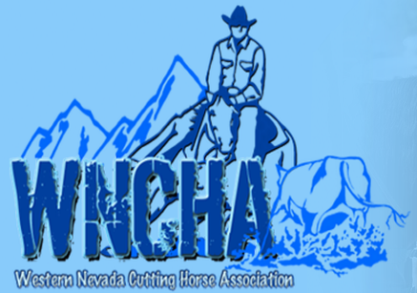
WESTERN NEVADA CUTTING HORSE ASSOCIATION
Nikki Chandler, Secretary
6100 Neil Road, Suite 500 – Reno, Nevada 89511

To whom it may concern:
The kickoff for the 2022 Western Nevada Cutting Horse Association show season is just around the corner with shows beginning in March and going through October. What an exciting season it is going to be as well!
WNCHA is seeking sponsorship opportunities from willing individuals, companies, and businesses with hopes to create bigger, better, and more consistent awards to our participants. Here are the levels of sponsorship and what the sponsor will get in return:
___ $500 sponsor (year-end award) -Banner at shows -Name/Business on website and Facebook, as well as Name/Business read at the shows
___ $250 sponsor (circuit award) -Name/Business on website and Facebook, as well as Name/Business read at the shows
___ $100 sponsor (concessions, photos, miscellaneous other related items) - Name/Business read at the shows
We, as a committed team, are appreciative of your interest in helping our club grow, succeed, and have an amazingly successful year. If you have any questions regarding a sponsorship opportunity, please feel free to reach out to any of the directors; We will all be glad to help answer any questions. Please, if you wish to sponsor and have any specific designations, mark a level, enclose a check to WNCHA, and place in the mail to
Debby Burns, Treasurer 715-310 Lake Leavitt Rd Susanville Ca 96130
We are very excited and can’t wait to see you in the show pen!
Thank you,

Kirk Ferris
WNCHA PRESIDENT

