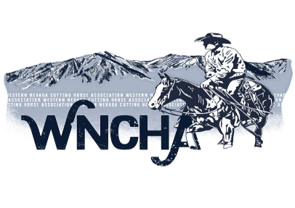
WESTERN NEVADA CUTTING HORSE ASSOCIATION
MEMBERSHIP APPLICATION
(All membership applications are subject to review by the Board of Directors)

Name:
Address:
City/State/Zip:
Phone: Cell:
Email Address:
NCHA #
Social Security Number:

Annual Dues: $50.00 plus $10,00 for each additional family member
Youth Dues: $10.00 each
Date Paid Check/Cash Amount
I want my newsletter: Emailed Mailed
Family memberships will receive one newsletter per family
Name Relationship NCHA #
Family Member(s)

Horse(s) Name(s) REGISTERED HORSES MUST BE SHOWN UNDER REGISTERED NAMES)

PLEASE MAKE CHECKS PAYABLE TO:
WNCHA

MAIL TO:
Zeona Cilonis
20965 Ames Lane
Reno, Nevada 89511
(775) 287-7018 Zaldiranch@att.net

